Activity 13.3

1. 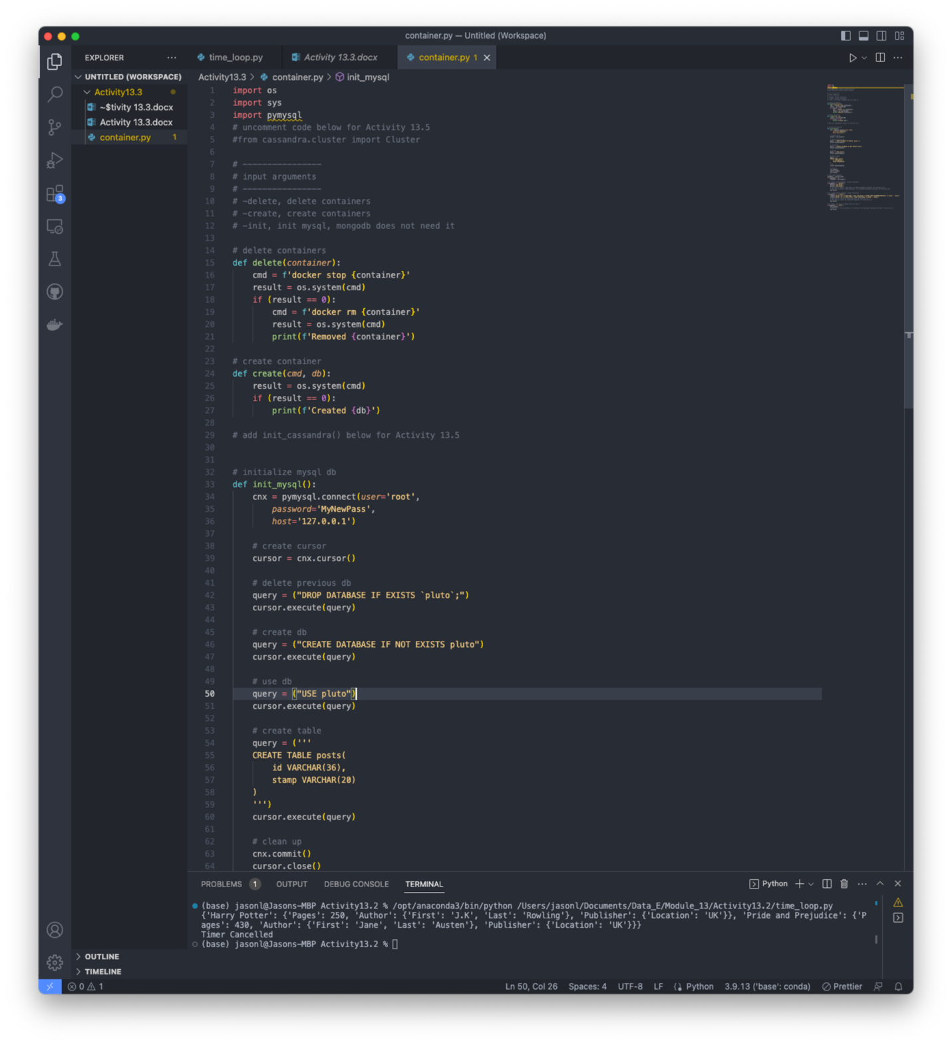
   1. Screenshot of new folder with container.py and code on activity sheet
2. Text

   Description automatically generated
   1. Correctly ran and created the databases.
3. Graphical user interface, text, application

   Description automatically generated
   1. Docker containers are open and running
4. 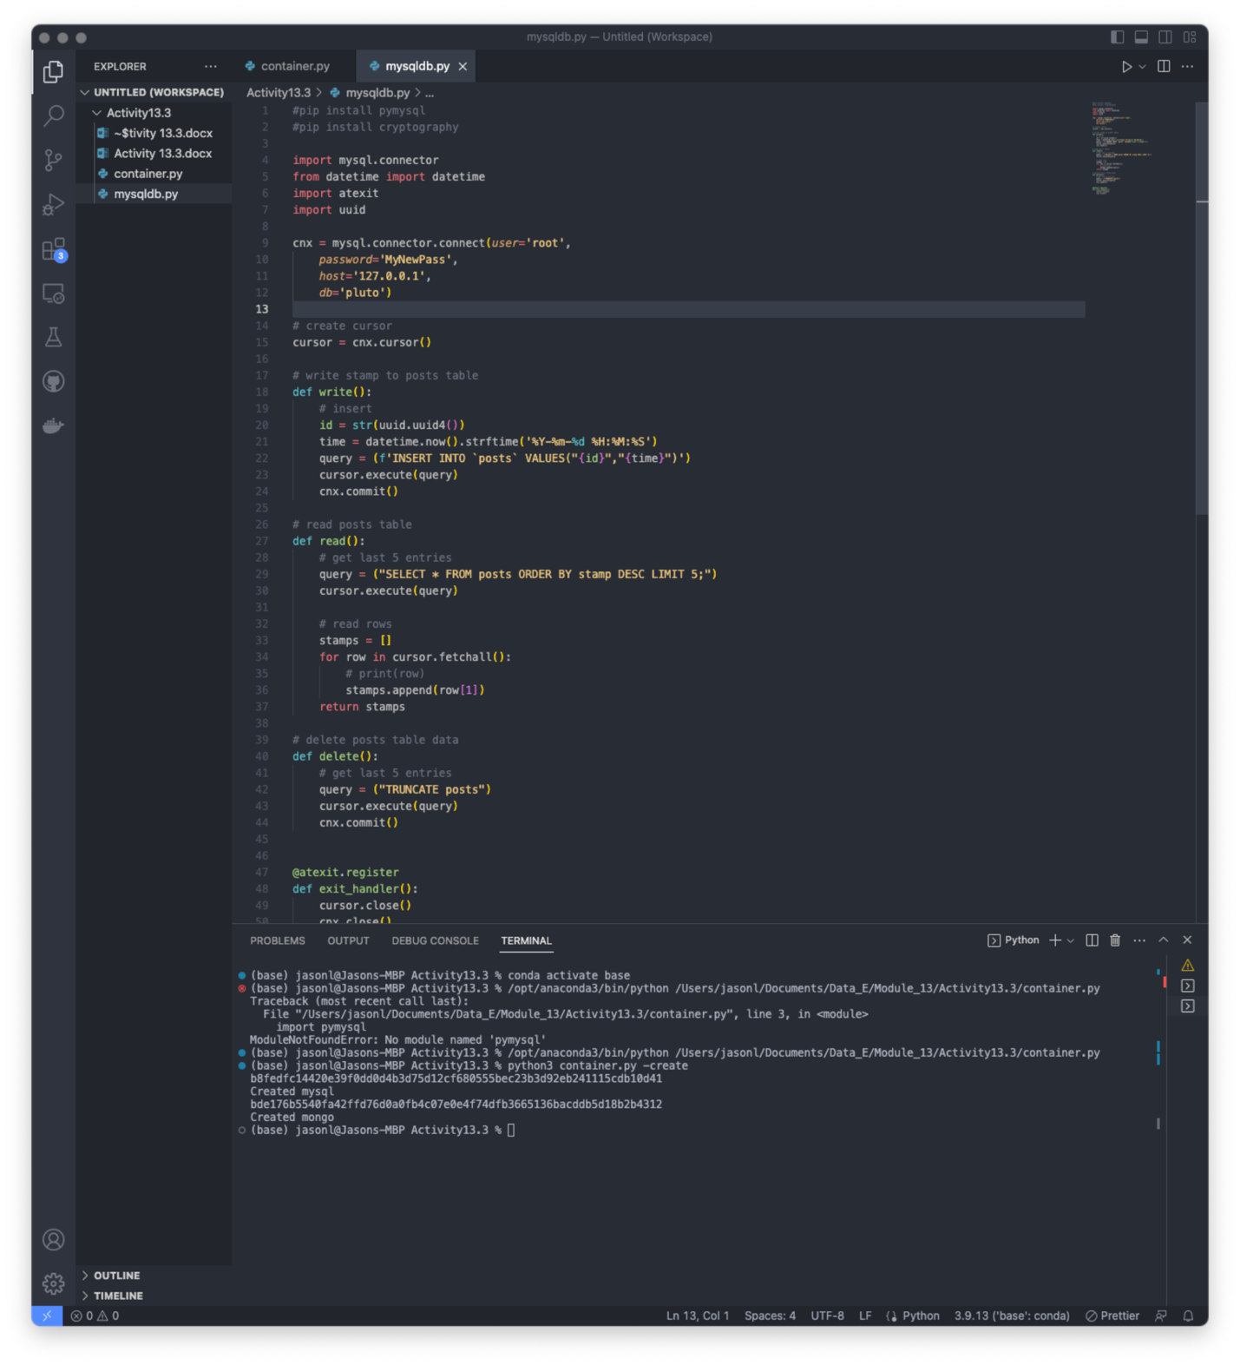
   1. New file has been created and code copied in.
5. A screenshot of a computer screen

   Description automatically generated
   1. New mongodb file has been created and text copied in.
6. A screenshot of a computer

   Description automatically generated with medium confidence
   1. New scheduler file was created and code copied in.
7. Text

   Description automatically generated
   1. Successfully ran the container command with -init as argument
8. Text

   Description automatically generated
   1. Scheduler is running and inputting values into the mysql and mondo databases.
9. Text

   Description automatically generated
   1. Killed terminal and then ran the container.py with -delete as the parameter. Shows that they were deleted.
10. Graphical user interface, application

    Description automatically generated
    1. Docker showing deleted containers.